**DAILY ONLINE ACTIVITIES SUMMARY**

|  |  |  |  |  |  |  |  |
| --- | --- | --- | --- | --- | --- | --- | --- |
| **Date:** | **11/06/2020** | | | | **Name:** | **Samrin Banu** | |
| **Sem & Sec** | **8th B** | | | | **USN:** | **4AL16C082** | |
| Online Test Summary | | | | | | | |
| **Subject** | | **SMS** | | | | | |
| **Max. Marks** | | **60** | | **Score** | | **60** | |
| Certification Course Summary | | | | | | | |
| **Course** | **GUVI** | | | | | | |
| **Certificate Provider** | | | **Python** | **Duration** | | | **26 hrs** |
| Coding Challenges | | | | | | | |
| **Problem Statement:** 1) Python Program to Illustrate Different Set Operations | | | | | | | |
| **Status: Solved** | | | | | | | |
| **Uploaded the report in Github** | | | | **YES** | | | |
| **If yes Repository name** | | | | **Samrinbanu** | | | |
| **Uploaded the report in slack** | | | | **YES** | | | |

Online test detail:

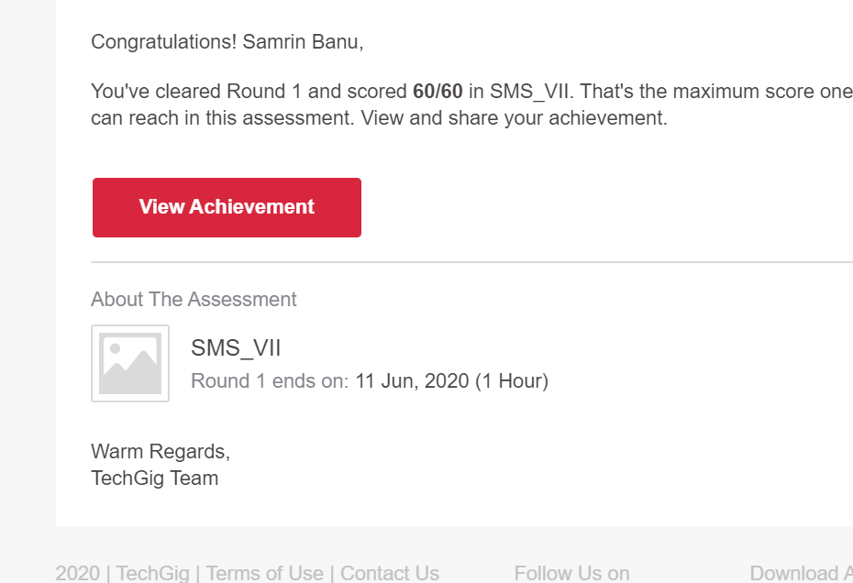

**Certification Course Details:**



# CODE:

Program no:1

# Program to perform different set operations like in mathematics

# define three sets

E = {0, 2, 4, 6, 8};

N = {1, 2, 3, 4, 5};

# set union

print("Union of E and N is",E | N)

# set intersection

print("Intersection of E and N is",E & N)

# set difference

print("Difference of E and N is",E - N)

# set symmetric difference

print("Symmetric difference of E and N is",E ^ N)